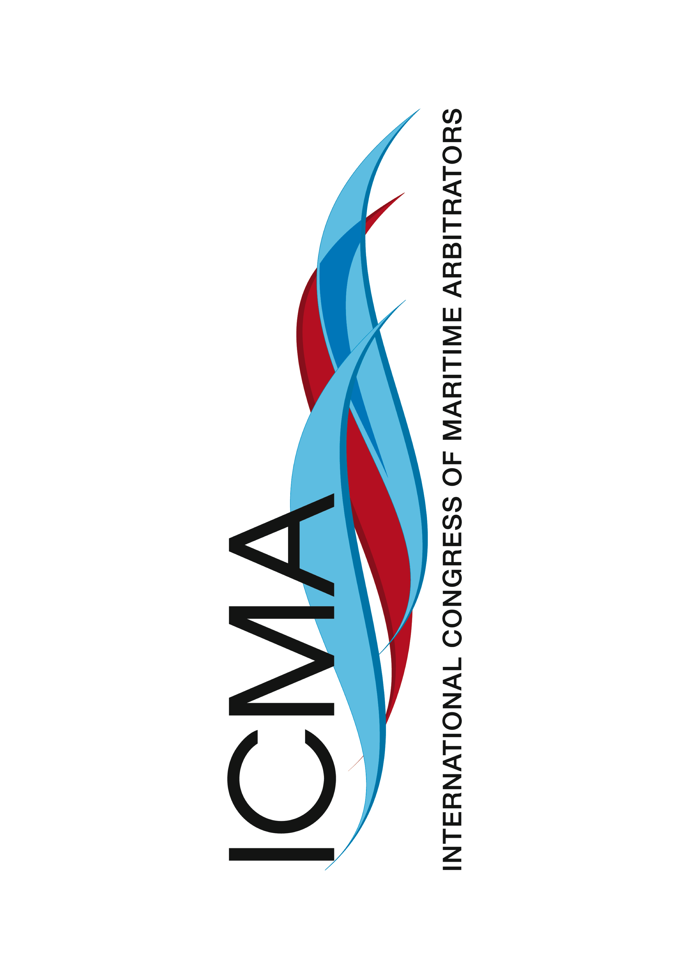

ICMA XIX Hong Kong – 11 to 15 May 2015

Highlights of the event:
- Cedric Barclay Memorial Lecture “Contributions to the English law of contract that started life as maritime arbitrations in Cedric's day” to be given by Lord Phillips of Worth Matravers, the former President of the Supreme Court of the United Kingdom
- Join the world’s top maritime arbitrators, lawyers and counsel
- Over 100 speakers will present summaries of their papers, which will cover the most important and topical issues of maritime arbitration and substantial law and practice
- All papers submitted by those attending the Congress will be made available on a USB stick to all registered delegates
- A mock arbitration will be held by 20 Essex Street and Quadrant Chambers
- Extensive social programme, both for delegates and accompanying persons
- Visit to the Hong Kong International Arbitration Centre and to the Hong Kong Maritime Museum
- Exclusive opportunity to join delegates to the ICCA-HKIAC HK Summit at the Happy Valley Racecourse

Register Now at:
www.ICMA2015HongKong.org

A division of the
Hong Kong International Arbitration Centre

